**1.0 Literature Review**

**1.1 Concept of Sustainability**

In project management, sustainability refers to using a holistic approach to managing a project's social, economic, and environmental components during its whole lifecycle. It necessitates giving the project's implications considerable thought and putting plans in place to lessen its negative effects while maximizing its good ones. Adopting sustainability entails realizing that projects are part of larger ecosystems and that their benefits to social justice, economic growth, and environmental preservation should be taken into account in addition to more conventional measures like cost and schedule.

**1.1.1 Project Challenge Management**

Project managers must navigate complications like resource limitations, stakeholder expectations, and legal obligations in order to effectively manage sustainability concerns. These challenges can include making sure that social inclusion is maintained, striking a balance between environmental stewardship and economic feasibility, and incorporating sustainability concepts into project planning, implementation, and assessment. Strong leadership, creative thinking, and a thorough understanding of sustainability principles are necessary for the effective management of these difficulties.

**1.1.2 Sustainability in Solar Panel Integration Project**

Achieving sustainability in a solar panel integration project involves careful consideration of economic, social, and environmental factors. Here are some strategies to promote sustainability in such projects:

1. **Environmental Impact Assessment**: Before initiating the solar panel installation, it's crucial to conduct an environmental impact assessment. This assessment should evaluate factors such as the site's geography, climate, and ecology to identify potential environmental impacts. By assessing risks like habitat disruption and land degradation, project planners can implement mitigation measures to minimize adverse effects (ISO 14040:2006 - Environmental Management — Life Cycle Assessment — Principles and Framework, n.d.).
2. **Adoption of Renewable Materials and Energy**: Incorporating renewable materials and energy sources into the project can enhance its sustainability. Utilizing eco-friendly materials for panel mounting structures, such as recycled aluminum or sustainably sourced wood, reduces the project's carbon footprint. Moreover, integrating energy-efficient components, such as inverters and batteries, enhances the overall sustainability of the solar power (— SDG Indicators, n.d.).
3. **Community Engagement and Benefit Sharing**: Engaging with local communities and stakeholders is vital for ensuring project acceptance and fostering sustainable development. Establishing transparent communication channels and conducting stakeholder consultations allow communities to voice concerns and provide input into project decision-making. Furthermore, implementing benefit-sharing mechanisms, such as community-owned solar initiatives or job training programs, ensures that the project delivers tangible benefits to the local population (Klees et al., 2012).
4. **Lifecycle Assessment and End-of-Life Management**: Assessing the lifecycle environmental impacts of solar panels and implementing effective end-of-life management strategies are essential for long-term sustainability. Conducting lifecycle assessments helps identify areas for improvement in panel manufacturing, transportation, installation, and decommissioning processes. Additionally, establishing take-back and recycling programs ensures proper disposal of decommissioned panels, minimizing waste and environmental pollution (Agencia Internacional de Energía, 2020).
5. **Monitoring and Performance Optimization**: Implementing a comprehensive monitoring and performance optimization plan is crucial for maximizing the project's efficiency and lifespan. Regular monitoring of solar panel performance, coupled with proactive maintenance and cleaning, ensures optimal energy generation and system reliability. Furthermore, leveraging data analytics and predictive maintenance techniques allows for early detection of issues and timely intervention, thereby enhancing the project's sustainability and return on investment (Solar Market Insight Report 2019 Q4 | SEIA, n.d.).

**1.1.2 Strategies to Achieve Project Sustainability**

Organizations must take a proactive stance and incorporate sustainability principles into all phases of the project lifecycle in order to achieve project sustainability. This entails establishing precise sustainability goals and objectives that complement the mission and core values of the company. carrying out comprehensive evaluations of sustainability to pinpoint possible effects and hazards. including local communities and other stakeholders in decision-making processes. putting into reality energy-efficient technology and renewable materials in construction and design. tracking and assessing project performance in relation to sustainability standards, and making necessary strategy adjustments to enhance results.

**1.2.1 Organization Profile**

The project's driving force, SolarGen Technologies Limited, is a top supplier of solar energy solutions dedicated to advancing environmentally friendly energy practices in Somalia and throughout Africa. With an emphasis on sustainability, SolarGen wants to lower the carbon footprint and improve energy efficiency of Hamar Boarding School by incorporating solar panel technology into its infrastructure. The goal of SolarGen is to give economically disadvantaged areas access to inexpensive energy, water, and irrigation solutions. Their goal is to give people all around Africa access to sustainable energy, water, and irrigation solutions while promoting environmental stewardship and economic empowerment.

**1.2.2 Mission**

The goal of SolarGen Technologies Limited is to give impoverished communities access to reasonably priced water, energy, and irrigation solutions so they may become economically independent. In order to guarantee that everyone has access to clean, dependable, and reasonably priced energy sources as well as safe drinking water and effective irrigation systems, SolarGen is dedicated to utilizing cutting-edge technologies and sustainable practices. SolarGen seeks to improve communities, raise people's standard of living, and support long-term economic growth and prosperity by attending to these pressing needs.

**1.2.3 Vision**

Delivering food, water, and energy security throughout Africa is SolarGen Technologies Limited's mission. Through leading the way in the implementation of sustainable energy solutions, SolarGen hopes to stimulate economic expansion, reduce poverty, and improve living standards across the continent. SolarGen sees a future in which every African community has access to sustainable food sources, clean and dependable energy, and safe drinking water through strategic collaborations and cutting-edge technologies. SolarGen aims to empower African countries to attain self-sufficiency, resilience, and wealth while preserving the environment for coming generations by tackling these basic needs.

**Introduction**

The ambitious "Brighter Future: Solar Panel Integration For Hamar Boarding School" project aims to transform the energy usage of the Mogadishu, Somalia-based Hamar Boarding School. The addition of solar panels to the school's infrastructure is a major step in the direction of sustainability, supporting international initiatives to promote renewable energy sources and fight climate change. Through the utilization of Somalia's plentiful solar energy resources, this project not only meets the energy requirements of the school but also establishes a model for sustainable development in the area. It is anticipated that the installation of solar panels will lessen the school's dependency on fossil fuels, lowering its carbon footprint and promoting a cleaner, a more environmentally friendly setting. Furthermore, this project has the potential to spread, encouraging other Somalian towns and organizations to adopt renewable energy solutions and achieving the nation's sustainability objectives.

**1.2.4 Project Background**

Situated in Mogadishu, KM4, Hamar Boarding School is a well-known educational establishment committed to offering high-quality education to kids, especially those from disadvantaged families. Notwithstanding its dedication to provide a top-notch education, the school encounters common difficulties shared by several establishments in the area, such as irregular electrical supply.   
Through the use of Somalia's plentiful solar energy, the project aims to address this issue. The project's goal is to produce clean, renewable energy on school property through the installation of solar panels, which will power the school's administrative buildings, dorms, and classrooms among other areas. The school's transition to solar energy not only lessens its carbon impact but also offers a long-term solution for its energy requirements, guaranteeing dependable access to electricity for years to come.

Beyond the school's immediate requirements, the project is significant because it sets an example for sustainable development in the area. The initiative intends to support Somalia's larger sustainability goals by encouraging other organizations and communities to adopt renewable energy solutions by showcasing the viability and advantages of solar energy integration.

**1.2.5 Project Proposal**

The project proposal provides comprehensive plans, including cost estimates, schedules, and feasibility studies, for the installation of solar panels. It also lists the anticipated advantages of the project, including lower energy expenses, better environmental results, and more chances for students to receive instruction on renewable energy technologies.

**1.2.6 Project Charter**

|  |  |
| --- | --- |
| **Project Charter** | |
| Project Name | Brighter Future: Solar Panel Integration For Hamar Boarding School |
| Project Description | The project aims to integrate solar panel technology into the infrastructure of Hamar Boarding School in Somalia, Mogadishu, to reduce its carbon footprint and enhance energy efficiency |
| Project Objectives | -Integrate solar panels into the school's infrastructure  - Reduce the school's reliance on fossil fuels  - Enhance energy efficiency at Hamar Boarding School |
| Project Scope | The project will involve the installation of solar panels on the school's premises, including classrooms, dormitories, and administrative buildings. The project will also include training sessions for school staff on the maintenance and operation of the solar panel system |
| Assumption | Availability of suitable solar panel technology in the region - Access to skilled labor for installation and maintenance - Support from school administration and staff for the project |
| Duration | The project will take place from 1st August 2024 to 20th August 2024. |
| Stakeholders | -Project Sponsor  - Project Manager  – Project Team  - Hamar Boarding School Administration and Staff  - Students and Parents - Local Community |
| Project Budget | The total planned budget for the project is $X (insert budget amount here). |
| Project Risks | Delays due to unforeseen technical issues or logistical challenges - Weather conditions affecting the installation schedule - Availability of skilled labor and materials - Budget overruns |
| Responsible Personals | Mohamed Aweis  Abdi  Ahmed |
| Approval | The project will be approved by the Project Sponsor and other key stakeholders before commencement |

**3.5 Statement Of work**

The target of the project, "Brighter Future: Solar Panel Integration For Hamar Boarding School," is to completely transform the Mogadishu, Somalia-based school's energy usage. The initiative aims to improve energy efficiency and lower the school's carbon footprint by incorporating solar panels into the infrastructure. This program supports international initiatives to develop renewable energy sources and fight climate change. To guarantee the project's success, the project team is dedicated to working in conjunction with stakeholders, such as the local community, parents, teachers, and administration of the school. Together, they hope to make Somalia greener and more sustainable as well as a better, more sustainable future for Hamar Boarding School.

# PROJECT COST MANAGEMENT AND PROJECT SCHDULING

|  |  |  |
| --- | --- | --- |
| **Project Name** | **Duration of the Project** | **Budget of the Project** |
| Solar Panel Integration for Xamar Boarding School | 21 Days | **$** 15,500 |

# Project Cost Management:

Project cost management encompasses various processes involved in planning, estimating, budgeting, and controlling the costs of a project. (COST MANAGEMENT CONCEPT AND PROJECT EVALUATION METHODS, n.d.)For the solar panel integration project at Xamar Boarding School, it involves the following key steps:

1. **Plan Cost Management:** This initial step involves outlining how project costs will be estimated, budgeted, and controlled throughout the project lifecycle.
2. **Estimate Costs:** Estimating the costs associated with solar panel procurement, electrical infrastructure upgrades, installation, training, and maintenance.
3. **Determine Budget:** Once the costs are estimated, a budget is determined, considering all project expenses to ensure financial feasibility and accountability.
4. **Control Costs:** Continuously monitoring project expenditures against the budget and taking corrective actions to manage costs within the approved budget.

# Cost Estimation Techniques:

The cost estimation process for the solar panel integration project at Xamar Boarding School involves employing various techniques tailored to the project's specific requirements:

**Bottom-Up Estimating:** This methodological approach involves breaking down the project into individual components, such as solar panel procurement, electrical upgrades, installation, training, and maintenance. Each component is evaluated independently before combining the findings to create an all-encompassing cost estimate. Given the intricate nature of the project and the diverse range of components involved, bottom-up estimating allows for a detailed analysis of each element, considering its unique challenges, materials, labor, and associated costs.

**Parametric Estimating:** Utilizing statistical data and mathematical models to estimate project costs based on historical data, industry benchmarks, and other relevant sources. While less detailed than bottom-up estimating, parametric estimating provides valuable insights into cost projections, particularly for standardized or repetitive project elements.

**Expert Judgment:** Seeking input from subject matter experts with experience in similar projects to provide insights and estimates based on their expertise. Expert judgment enhances the accuracy and reliability of cost estimates, especially in complex projects where historical data may be limited or unavailable.

# Cost Estimation for Solar Panel Integration:

The cost estimation for solar panel integration at Xamar Boarding School involves the following components:

| **Activities** | **Description** | **Cost ($)** |
| --- | --- | --- |
| Site Assessment | Conducting site assessment to determine suitability for solar panel installation | 500 |
| Solar Panel Procurement | Procuring solar panels and related equipment | 4000 |
| Electrical Infrastructure Upgrade | Upgrading electrical infrastructure to support solar panel integration | 3000 |
| Installation | Installing solar panels and connecting them to the electrical system | 2500 |
| Training & Capacity Building | Training staff on system operation and maintenance procedures | 1000 |
| Monitoring & Maintenance | Implementing monitoring systems and scheduling maintenance | 1000 |
| Other Costs | Including permitting, indirect costs, and contingency budget | 1500 |
| **Total** | **Total project cost** | **$15,500** |

Efficient project cost management is essential for ensuring the successful implementation of the solar panel integration project at Xamar Boarding School. By employing the bottom-up estimating technique, supported by parametric estimating and expert judgment, we aim to deliver a cost-effective and sustainable solution that meets the school's energy needs while staying within the allocated budget.

# Work Break-Down Structure (WBS)

# 

# Detailed WBS for Solar Panel Installation at Xamar boarding School’

| No. | Main Task | No. Sub-task | Responsible Agent | Deadline |
| --- | --- | --- | --- | --- |
| 1 | Project Planning | 1.1 Assess Site Feasibility | SolarGen |  |
|  |  | 1.1.1 Analyze Weather Patterns | SolarGen |  |
|  |  | 1.1.1.1 Conduct Site Assessment | SolarGen |  |
|  |  | 1.1.1.2 Inspect Site Conditions | SolarGen |  |
|  |  | 1.2 Define Project Scope | Site engineer |  |
|  |  | 1.2.1 Identify Project Objectives | Site engineer |  |
|  |  | 1.2.1.1 Define Project Deliverables | Site engineer |  |
|  |  | 1.3 Obtain Permits | SolarGen |  |
|  |  | 1.3.1 Research Permit Requirements | SolarGen |  |
|  |  | 1.3.1.2 Secure Permit Approvals | SolarGen |  |
| 2 | Solar Procurement & Installation | 2.1 Research Technology & Suppliers | Site engineer |  |
|  |  | 2.1.1 Evaluate Solar Panel Options | Site engineer |  |
|  |  | 2.1.1.2 Identify Potential Suppliers | Site engineer |  |
|  |  | 2.2 Coordinate Delivery | SolarGen |  |
|  |  | 2.2.1 Secure Purchase Order | SolarGen |  |
|  |  | 2.2.1.2 Track Delivery Schedule | SolarGen |  |
|  |  | 2.3 Install Solar Panels | Contractors |  |
|  |  | 2.3.1 Prepare Installation Site | Contractors |  |
|  |  | 2.3.1.2 Install and Connect Panels | Contractors |  |
| 3 | Electrical Infrastructure | 3.1 Assess Current Electrical Setup | Site engineer |  |
|  |  | 3.1.1 Conduct Electrical Audit | Site engineer |  |
|  |  | 3.1.1.2 Determine Upgrade Needs | Site engineer |  |
|  |  | 3.2 Upgrade for Integration | Site engineer |  |
|  |  | 3.2.1 Design Upgrade Plan | Site engineer |  |
|  |  | 3.2.1.2 Implement Electrical Upgrades | Site engineer |  |
|  |  | 3.3 Ensure Compliance | Site engineer |  |
|  |  | 3.3.1 Research Electrical Codes | Site engineer |  |
|  |  | 3.3.1.2 Obtain Electrical Inspection | SolarGen |  |
| 4 | Training & Capacity Building | 4.1 Develop Training Materials | Site engineer |  |
|  |  | 4.1.1 Create Operation Manuals | Site engineer |  |
|  |  | 4.1.1.2 Develop Maintenance Procedures | Site engineer |  |
|  |  | 4.2 Conduct Training Sessions | SolarGen |  |
|  |  | 4.2.1 Train Staff on System Operation | SolarGen |  |
|  |  | 4.2.1.2 Train Staff on Maintenance Procedures | SolarGen |  |
|  |  | 4.3 Provide Ongoing Support | SolarGen |  |
|  |  | 4.3.1 Offer Technical Assistance | SolarGen |  |
|  |  | 4.3.1.2 Address Questions and Concerns | SolarGen |  |
| 5 | Monitoring & Maintenance | 5.1 Implement Monitoring Systems | Contractors |  |
|  |  | 5.1.1 Install Data Tracking Equipment | Contractors |  |
|  |  | 5.1.1.2 Configure Monitoring Software | Contractors |  |
|  |  | 5.2 Schedule Maintenance | SolarGen |  |
|  |  | 5.2.1 Develop Maintenance Schedule | SolarGen |  |
|  |  | 5.2.1.2 Assign Maintenance Tasks | SolarGen |  |
|  |  | 5.3 Address Issues Promptly | SolarGen |  |

# Network diagram

A network diagram serves as a visual representation illustrating the sequence and dependencies of tasks and activities within the Solar Panel Project. It aids in comprehending the interconnections between various project activities, their durations, and the critical path necessary for project completion.

For the team at Xamar boarding school, crafting a network diagram for the Solar Panel Project offers invaluable insights into the project's workflow. By delineating the logical relationships among activities, this diagram empowers the team to meticulously plan, schedule, and monitor the project's progress. In line with the guidelines provided by the Project Management Institute (PMI), a network diagram for the Solar Panel Project acts as a schematic display of the logical sequencing of project activities. This visualization facilitates the development of project schedules, identification of critical path activities, and fosters seamless communication among project team members. (PERT Network, CPM Network, and Precedence Diagram | PMI, n.d.).

# Table of dependencies

| **Task** | **Description** | **Predecessors** | **Duration (Days)** |
| --- | --- | --- | --- |
| A | Site Assessment | - | 3 |
| B | Solar Panel Procurement | A | 3 |
| C | Electrical Infrastructure Upgrade | A | 5 |
| D | Install Solar Panels | B | 4 |
| E | Electrical System Upgrade | C | 3 |
| F | Training Session | D, E | 3 |

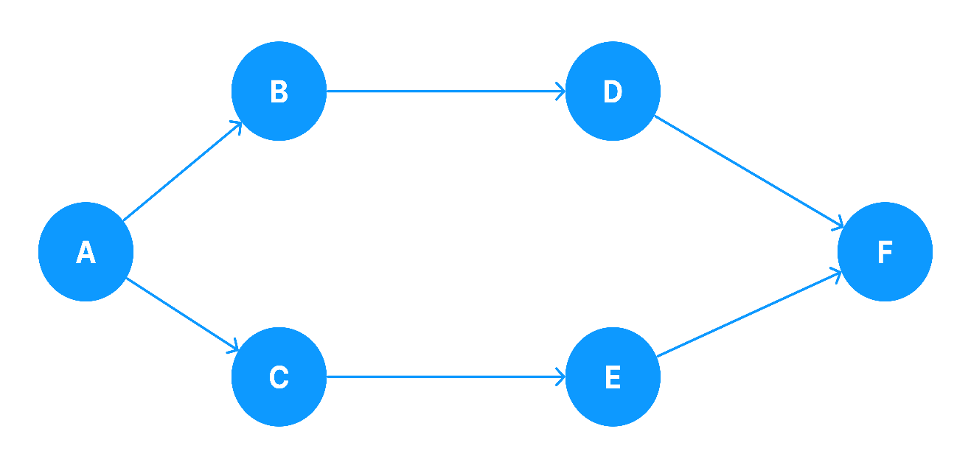

# CPM network diagram

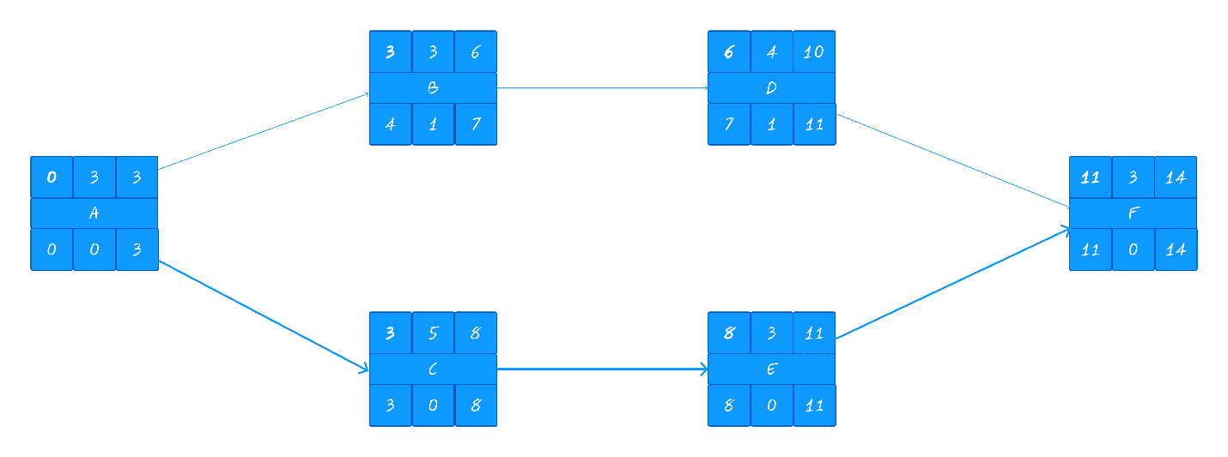

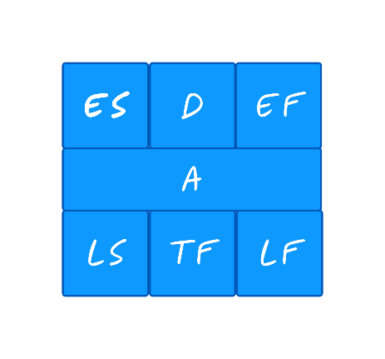ES = Early Start.  
EF = Early Finish.  
  
LS = Late Start.   
LF = Late Finish.  
  
D = Duration.  
TF = Total Float.  
ES = ES + D  
LS = LF - D  
LF = ES-D          
TF = LF - EF or LS - ES

CP 🡺

**3.0 Project Resource Management**

Resource management is critical for the successful completion of the "Solar Panel Integration for Xamar Boarding School" project. This involves planning, scheduling, and allocating resources efficiently to ensure project objectives are met. Effective human resource management is a key aspect of this process, involving the planning, acquisition, development, and leadership of project team members (*6th Edition PMBOK® Guide–Process 9.1 Plan Resource Management: Tools and Techniques | 4squareviews*, n.d.).

**3.1 Human Resource Plan**

Human resource management is integral to the success of the "Solar Panel Integration for Xamar Boarding School" project. It involves a strategic approach to managing individuals who contribute to achieving project objectives. This plan encompasses various phases, including planning, procuring, nurturing, and guiding team members.

| **No** | **Role** | **Type of Contract** | **No. of Staff Required** |
| --- | --- | --- | --- |
| 1 | Project Manager | Full time | 1 |
| 2 | Renewable Energy Engineer | Full time | 1 |
| 3 | Solar Panel Installation Team | Full time | 5 |
| 4 | Community Engagement Coordinator | Full time | 1 |
| 5 | Electrical Engineer | Part-time | 1 |
| 6 | Training and Education Specialist | Part-time | 1 |
| 7 | Health and Safety Officer | Full time | 1 |

**3.1.1 Roles and Duties for the Project Team**

1. **Project Manager:** The Project Manager will oversee the project's planning, execution, and closing phases, ensuring that project objectives are met within the specified constraints.
2. **Renewable Energy Engineer:** An expert in renewable energy systems will be hired to design, implement, and monitor the renewable energy solutions tailored to the needs of rural communities.
3. **Solar Panel Installation Team:** Hired through a local contractor experienced in solar energy projects, responsible for the physical installation of solar panels.
4. **Community Outreach Coordinator:** This role involves engaging with local communities, gathering requirements, and ensuring their active participation throughout the project lifecycle.
5. **Electrical Engineer:** The electrical technicians will be responsible for the installation, maintenance, and troubleshooting of renewable energy systems in rural areas.
6. **Training and Education Specialist:** This specialist will provide training sessions to community members on the operation and maintenance of renewable energy systems, empowering them to manage the systems independently.
7. **Health and Safety Officer:** Responsible for implementing safety protocols and ensuring the well-being of project team members and community members during the project's execution.

Additionally, a Quality Control Specialist will play a crucial role in ensuring that products or services meet established quality standards and that the processes for achieving this quality are well-defined and consistently followed. Their role and responsibilities will be further detailed in the project quality management plan.

**3.1.2 Resource Acquisition**

* The project manager will be selected internally within the organization, ensuring familiarity with the school's processes and requirements.
* Site engineers will be recruited externally, with a focus on individuals experienced in solar panel installation and integration.
* Contractors for electrical infrastructure and solar panel installation will be hired through reputable firms with a proven track record in similar projects.
* Additional staff required for project management and implementation will be sourced based on skill sets and project needs.

**3.1.3 Resource Management**

* The project manager will oversee the management of team members, including task assignment, performance monitoring, and conflict resolution.
* Site engineers will assist in managing the technical aspects of the project and coordinating with contractors and suppliers.
* Regular communication channels will be established to ensure effective coordination among team members and stakeholders.

**3.1.4 Resource Development**

* Training sessions will be organized for site engineers and project team members to enhance their skills in solar panel installation, electrical wiring, and safety protocols.
* Continuous learning opportunities will be provided to ensure team members are up-to-date with the latest technology and best practices in solar energy integration.

**3.1.5 Team Building**

* Team-building activities will be organized to foster collaboration, communication, and trust among project team members.
* Emphasis will be placed on creating a positive work environment where team members feel motivated and valued.

**3.1.6 Performance Management**

* The project manager and site engineers will regularly assess team performance, provide feedback, and recognize achievements to ensure alignment with project goals and objectives.
* Performance reviews will be conducted periodically to identify areas for improvement and address any issues proactively.

**3.2 RACI Assignment Matrix**

The Responsible, Accountable, Consulted, and Informed (RACI) matrix clarifies roles and responsibilities within the project team:(Dwi et al., 2021)

| **Task** | **Project Manager** | **Site Engineers** | **Contractors** | **Other Team Members** |
| --- | --- | --- | --- | --- |
| Project Planning | A | R | C | I |
| Solar Panel Procurement | R | A | C | I |
| Electrical Infrastructure | R | A | C | I |
| Installation & Integration | R | A | C | I |
| Training & Capacity Building | R | C | A | I |
| Performance Monitoring | R | C | A | I |

* Responsible (R): Individuals responsible for completing the task.
* Accountable (A): Individuals ultimately accountable for the task's success.
* Consulted (C): Individuals providing input and expertise for the task.
* Informed (I): Individuals who need to be kept informed about the task's progress.

**3.3 Organizational Structure**

Given the interdisciplinary nature of the project and the need for collaboration among various stakeholders, a matrix organizational structure will be adopted. This structure allows for efficient resource utilization and expertise sharing across functional departments, ensuring the successful completion of the project.

**REFERENCE**

*— SDG Indicators*. (n.d.). Retrieved March 22, 2024, from https://unstats.un.org/sdgs/report/2023/

*6th Edition PMBOK® Guide–Process 9.1 Plan Resource Management: Tools and Techniques | 4squareviews*. (n.d.). Retrieved March 22, 2024, from https://4squareviews.com/2018/06/06/6th-edition-pmbok-guide-process-9-1-plan-resource-management-tools-and-techniques/

Agencia Internacional de Energía. (2020). Renewable capacity statistics 2020 International Renewable Energy Agency. *Irena*, 66. https://tinyurl.com/2p8ws7dm

Dwi, R., Suhanda, P., & Pratami, D. (2021). RACI Matrix Design for Managing Stakeholders in Project Case Study of PT. XYZ. *International Journal of Innovation in Enterprise System*, *5*(02), 122–133. https://doi.org/10.25124/IJIES.V5I02.134

*ISO 14040:2006 - Environmental management — Life cycle assessment — Principles and framework*. (n.d.). Retrieved March 22, 2024, from https://www.iso.org/standard/37456.html

Klees, S. J., Samoff, J., & Stromquist, N. P. (2012). Human Rights in the World Bank 2020 Education Strategy. In *The World Bank and Education: Critiques and Alternatives*. Brill. https://doi.org/10.1007/978-94-6091-903-9

*PERT network, CPM network, and Precedence diagram | PMI*. (n.d.). Retrieved March 22, 2024, from https://www.pmi.org/learning/library/pert-cpm-network-precedence-diagram-3736

*Solar Market Insight Report 2019 Q4 | SEIA*. (n.d.). Retrieved March 22, 2024, from https://www.seia.org/research-resources/solar-market-insight-report-2019-q4

*View of COST MANAGEMENT CONCEPT AND PROJECT EVALUATION METHODS*. (n.d.). Retrieved March 22, 2024, from https://aseestant.ceon.rs/index.php/jouproman/article/view/21143/7848